**Lab 2 – SQL**

**Each problem is worth one point. No partial credit will be given. This lab is worth a total of 20 points.**

**Place all answers into ONE .sql file. Attach that file to the Dropbox for Lab 2 in D2L. Only one .sql file will be accepted.**

**1. Explain the purpose of a WHERE clause (submit this as an SQL comment)?**

**\*\*\* Use the tables from the AP table space for the following questions \*\*\***

**2. Display all invoices where the vendor id equals 34. Use the invoices table.**



**3. Display all invoices where the total of the invoice is $356.48. Use the invoices table.**



**4. Display all invoices where the invoice id is either 81, 82 or 90. You must use the IN**

**operator to receive credit. Use the invoices table.**

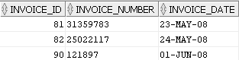

**5. Display all invoices where the vendor id is less than or equal to 44. Use the invoices table.**

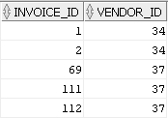

**6. Display all invoices where the credit total is not equal to zero. Use the invoices table.**

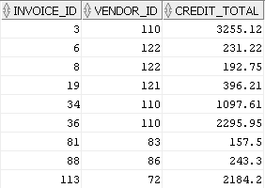

**7. Display all invoices where the invoice date is equal to May 1, 2008. Use the invoices table.**

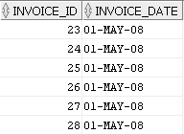

**8. Display all invoices where the payment total is between 100 and 115, inclusive. Use the**

**invoices table.**

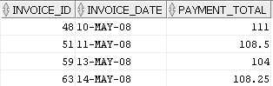

**9. Display all invoices where the invoice date is between May 1, 2008 and May 8, 2008,**

**inclusive. You must use the Between operator to receive credit. Use the invoices table.**

**Partial result set (15 rows total)**

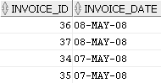

**10. Display all invoices where the invoice number starts with a capital P. Use the invoices**

**table.**

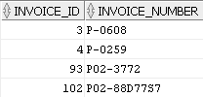

**11. Display all invoices where the invoice number starts with a capital P followed by a dash**

**followed by a 3. Use the invoices table.**



**12. Display all invoices where the invoice number ends with a –X (dash followed by a capital**

**X). Use the invoices table.**



**13. Display all invoices where the invoice number contains a double 11 (i.e. 11). The invoice**

**number must not start with a 1 or end with a 1. Use the invoices table.**



**14. Display all invoices where the invoice number has a zero as the second character and a 3**

**as the fourth character. Use the invoices table.**



**15. Display all invoices where the payment date contains a null value. Use the invoices**

**table.**

**Partial result set (40 rows total)**

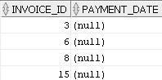

**16. Display all invoices where the payment date does not contain a null value. Use the**

**invoices table.**

**Partial result set (74 rows total)**

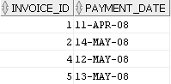

**17. Display all invoices where the payment total amount is zero and the invoice total is**

**greater than $100. Use the invoices table.**

**Partial result set (18 rows total)**

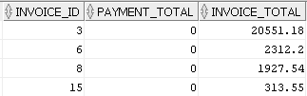

**18. Display all invoices where the payment total amount is between zero and $25, inclusive**

**or the invoice total is greater than $100. Use the invoices table.**

**Partial result set (97 rows total)**

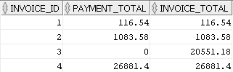

**19. Display all invoices where the terms id is not 1 or 2 or 3 or 4. You must use an IN**

**operator to receive credit. Use the invoices table.**



**20. Display all invoices where the invoice date is either May 1, 2008 or May 17, 2008 and**

**payment total amount is zero. You must use the OR and AND operators to receive**

**credit. Use the invoices table.**

